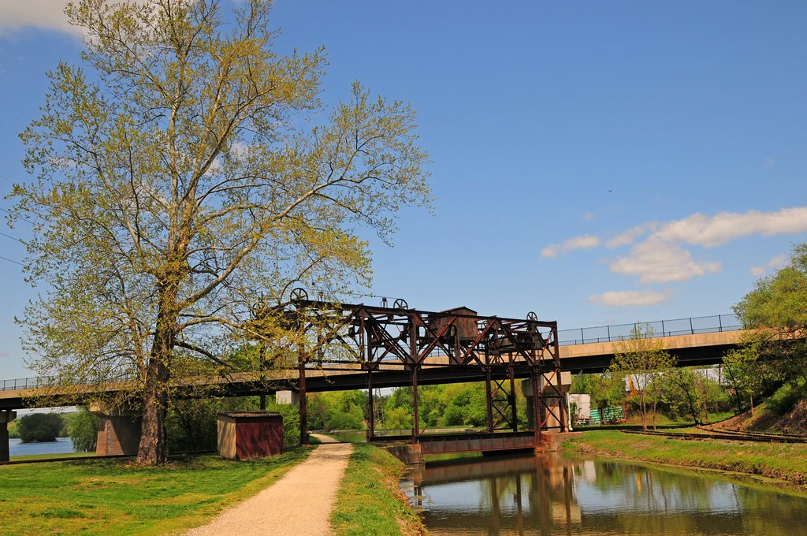
The state of Maryland is home to several bodies of water. Those bodies of water both big and
small play an important role in our everyday lives. With new development as well as old there has been an increase
in erosion causing sediments and other pollutants to build in our waterways.
The Town of Williamsport is continuously working to help provide solutions to lessen the harmful
impacts that stormwater runoff can cause. The Town of Williamsport has implemented many facets to address these issues, such as removing
refuge along tributaries, as well as working with the Dept. of Natural Resources to plant trees and educate our town residents on how they can help contribute to the MS4 process.
If you would like to speak with someone or express any concerns about stormwater management please contact
Donnie Stotelmyer, Town Manager at 301-223-7711

For more information please visit the State of Maryland Stormwater page at
https://mde.maryland.gov/programs/Water/StormwaterManagementProgram/Pages/index.aspx

